AAUW Car License Frame Order Form

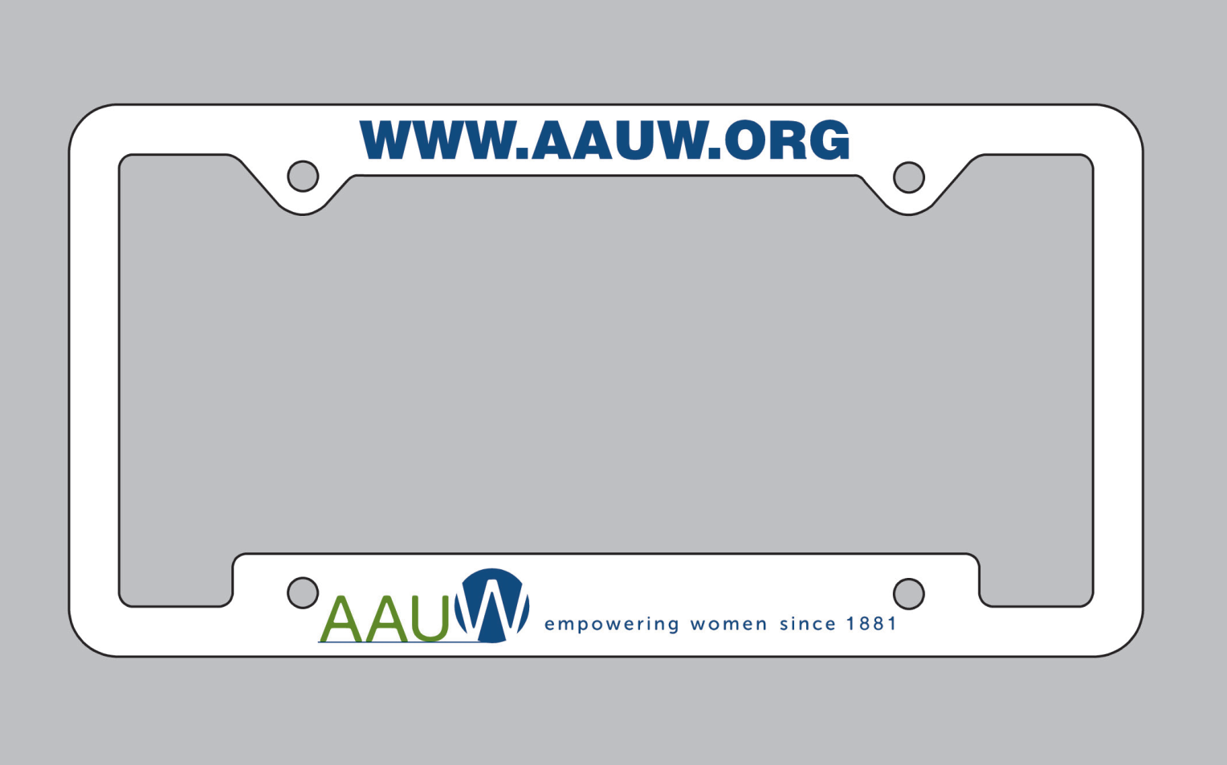

AAUW-Half Moon Bay
PO Box 1414
El Granada, CA 94018

Address
Sold To | Ship To
Phone | Ship By

Quantity | Item/Description | Donation/Item | Subtotal
 | White frame with www.aauw.org top, logo and tag line on bottom | $ 20.00 each
 | Note: If bought at the AAUW conference , no shipping charge
Total
Shipping Charge ($5/frame within USA)
Amount Due ($USD)

Money order or check payable to: Maura Jones

If you have any questions on this fundraiser, please email to: mauraijones@yahoo.com

